CSE 3024 LAB – WEB MINING
DHRUBANKA DUTTA – 17BCE1019
L – 33,34 . DATE - 11.3.19
NAIVE BAYES CLASSIFICATION

CODE :
from csv import reader

class NaiveBayesClassifier(object):

def __init__(self, dataset_filename, test_component_filename):
csvfile = open(dataset_filename, 'r')
self.dataset_ = list(reader(csvfile))
csvfile1 = open(test_component_filename, 'r')
self.test_component_ = list(reader(csvfile1))[0]
print('\nExisitng entries')
for row in self.dataset_:
print(row)
print('')
print('Attribute of new entry')
print(self.test_component_)
print('')

def separateDataset(self):
self.total_length = len(self.dataset_) + 0.0
self.separate_ = {}
self.probabilities_ = {}
for row in self.dataset_:
if row[-1] not in self.separate_:
self.separate_[row[-1]] = []
self.separate_[row[-1]].append(row[:-1])
for i in self.separate_:
self.probabilities_[i] = (len(self.separate_[i]) + 0.0) / self.total_length

def predict(self):
self.best_probability = 0
self.best_class = ''
for i in self.separate_:
temp_probability = 1
for j, item in enumerate(self.test_component_):
count = 0
for k in self.separate_[i]:
if k[j] == item:
count = count + 1
prob = count / len(self.separate_[i])
temp_probability *= prob
temp_probability *= self.probabilities_[i]
print('Class %s probability %.4f' % (i, temp_probability))
if temp_probability > self.best_probability:
self.best_probability = temp_probability
self.best_class = i
print('\nThe given X belongs to clss %s, probability :%.4f\n' % (self.best_class, self.best_probability))

## Main Code
dataset_file = input('Enter the name of the dataset file: ')
test_component_file = input('Enter the name of the test file: ')
nvc = NaiveBayesClassifier(dataset_file, test_component_file)
nvc.separateDataset()
nvc.predict()

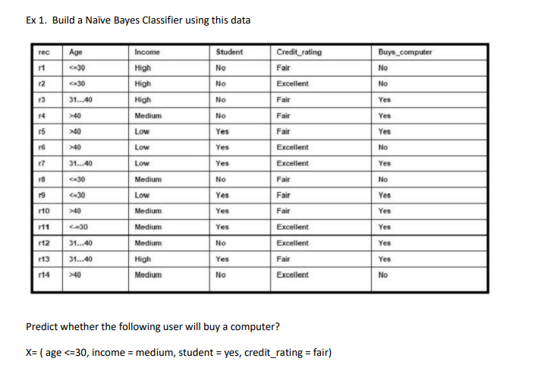
PART 1 :

AGE Income Student Credit_Rating Buys_Computer

AGE -

1 - <=30
2 - 31..40
3 - >=40

INCOME -

3 – High
2 – Medium
1 - Low

STUDENT -

0 – No
1 – Yes

CREDIT_RATING -

0 – Fair
1 – Excellent

BUYS_COMPUTER -

0 – No
1 – Yes

New entry -

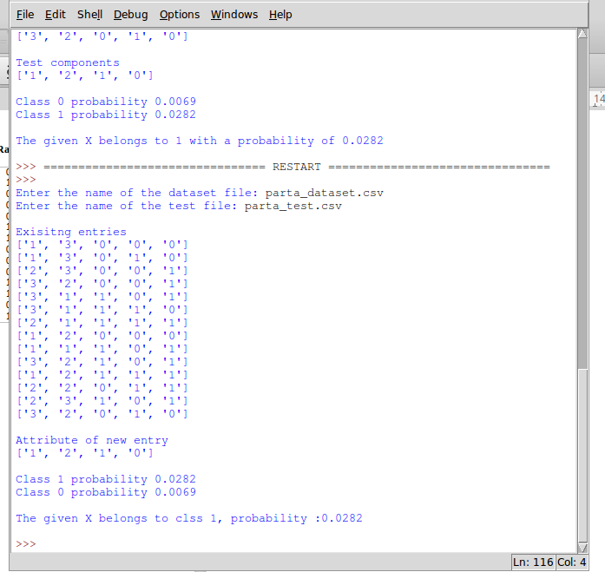

PART B -

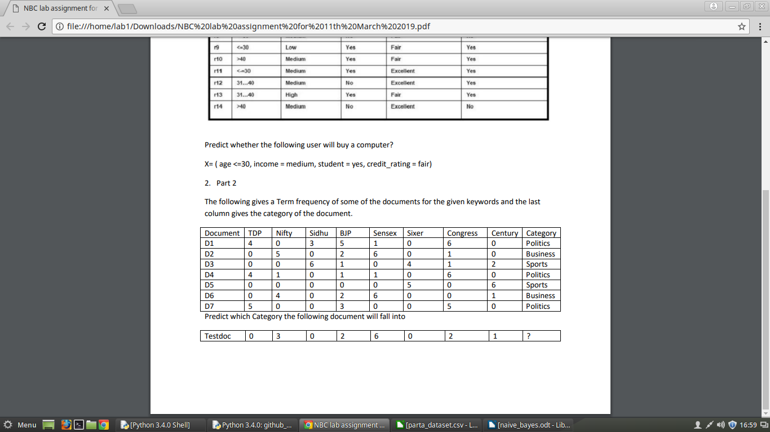

For category -

1 – Politics
2 – Business
3 – Sports

For entire table -

0 – if >=2
1 – if <2

NEW DATASET -

NEW TEST -

